Axle Project

17th June 2013 to 17th July 2013

MVML-Chakan

●●●

Aditya Oak

4th year Mechanical Engineering

Lokmanya Tilak College Of Engineering, Navi Mumbai

●●●

Objective:

Study the effect of contact pattern on differential assembly due to variation in assembly components using factorial experiment and FMEA analysis.

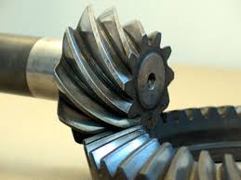

*AXLE*

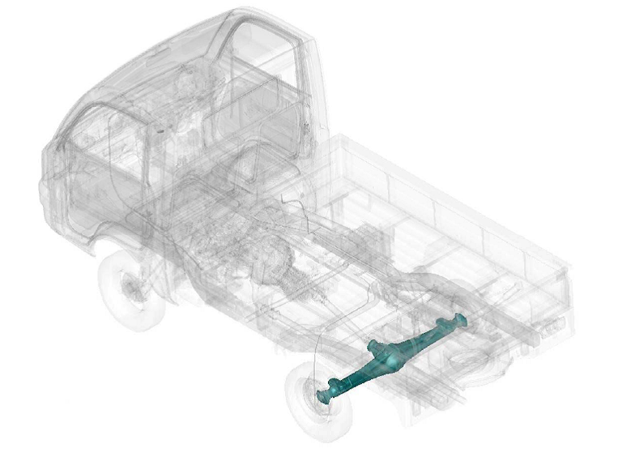

Axle is the part through which power is transmitted to the wheels. It consists of the differential and the drive shafts.

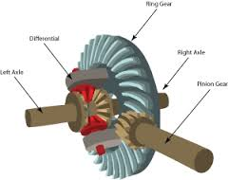The differential is used to maintain the torque transmitted to the wheels especially when the vehicle is taking turns. The final velocity reduction from engine is done in the differential.

The drive shafts are made from materials with high torsional strength.

* Differential-
* Ring gear fitted on the diff. Case.
* Pinion shaft gear meshed with ring gear.
* Pinion gears meshed with side gears.
* Companion flange assembled, which connects differential to propeller shaft.
* Dust shield for protecting axle components from dust.
* Pinion oil seal to prevent leakage of lubricating oil.
* Spacer.
* Pinion and ring gear together make the hypoid gears.
* Contact pattern- Contact between hypoid gears. Every pair of hypoid gears has a distinct pattern.
* Backlash- clearance distance between a pair of meshed teeth. It’s indispensable. It should neither be zero, nor very much greater than zero.
* Axle-Types- Banjo beam, Salisbury.

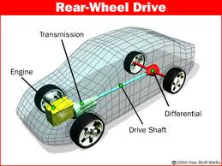

***AXLE ASSEMBLY***

*What is FBD (Functional Block Diagram).*

It is the sequential representation of a process along with the sub-parts that contribute in its flow .

Bearing mounts

4 bolts to hold wheel

Appropriate shim.

No relative motion

Top gears roll while turn

Universal Joint

Top and side gear mesh

Side and top gears

Proper meshing

Banjo Beam

***Nomenclature***

**Backlash**: The amount by which a tooth space exceeds the thickness of an engaging tooth.  
Or The play between the mating teeth of gears or how tightly the ring and pinion gears mesh together.

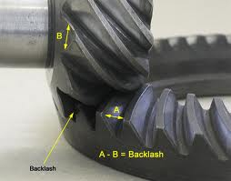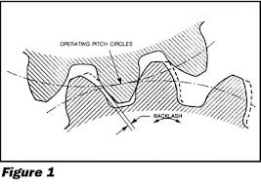

**Contact Pattern**: The area of impression of the pinion on the ring gear on its teeth surfaces.

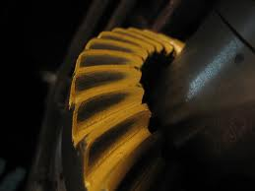

**Factorial experiment:**

In [statistics](http://en.wikipedia.org/wiki/Statistics), a full **factorial experiment** is an experiment whose design consists of two or more factors, each with discrete possible values or "levels", and whose [experimental units](http://en.wikipedia.org/wiki/Experimental_unit) take on all possible combinations of these levels across all such factors

Such an experiment allows the investigator to study the effect of each factor on the [response variable](http://en.wikipedia.org/wiki/Response_variable), as well as the effects of [interactions](http://en.wikipedia.org/wiki/Interaction_(statistics)) between factors on the response variable.

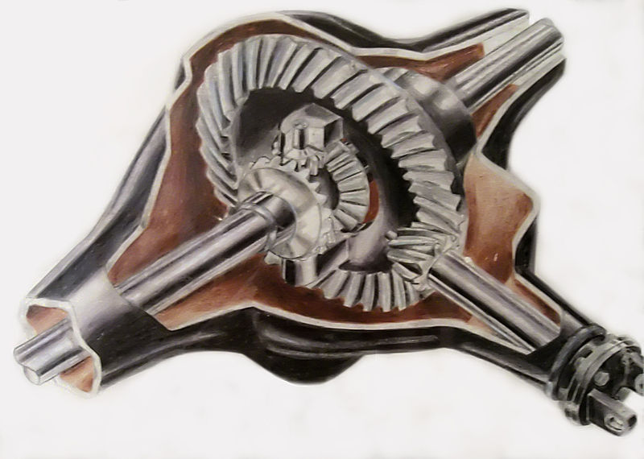

***Data generation using factorial experiment***

**Housing dist.- Bearing height - (Pinion mounting dist.+ pinion head variation) = Pinion positioning shim value.**

For every value of housing tolerance, bearing height tolerance and pinion head variation, difference was calculated. A histogram plot of differences was made and studied.

Based on that range was defined to suggest the optimum use of shim size generated from the data.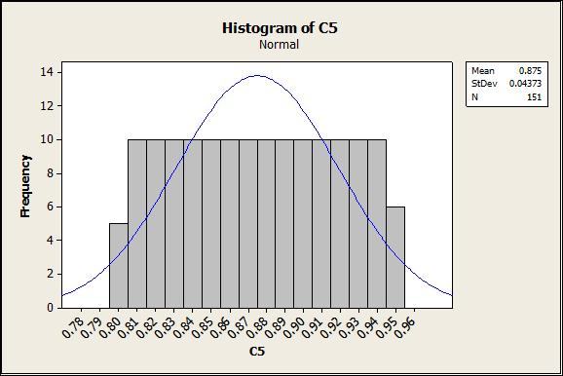

***F M E A***

**Failure mode and effect analysis** (**FMEA**) was one of the first systematic techniques for failure analysis. It was developed by [reliability engineers](http://en.wikipedia.org/wiki/Reliability_engineering) in the 1950s to study problems that might arise from malfunctions of military systems. An FMEA is often the first step of a system reliability study. It involves reviewing as many components, assemblies, and subsystems as possible to identify failure modes, and their causes and effects. For each component, the failure modes and their resulting effects on the rest of the system are recorded in a specific FMEA worksheet. There are numerous variations of such worksheets. A FMEA is mainly a qualitative analysis. A few different types of FMEA analysis exist, like Functional, Design and Process FMEA. Sometimes the FMEA is called [FMECA](http://en.wikipedia.org/wiki/FMECA) to indicate that Criticality analysis is performed also.

An FMEA is an [Inductive reasoning](http://en.wikipedia.org/wiki/Inductive_reasoning) (forward logic) single point of failure analysis and is a core task in [reliability engineering](http://en.wikipedia.org/wiki/Reliability_engineering), [safety engineering](http://en.wikipedia.org/wiki/Safety_engineering) and [quality engineering](http://en.wikipedia.org/wiki/Quality_engineering) (Quality engineering is specially concerned with the "Process" ((Manufacturing and Assembly) type of FMEA. A successful FMEA activity helps to identify potential failure modes based on experience with similar products and processes or based on common physics of failure logic. It is widely used in development and manufacturing industries in various phases of the product life cycle. *Effects analysis* refers to studying the consequences of those failures on different system levels.

Functional analyses are needed as an input to determine correct failure modes, at all system levels, both for functional FMEA or Piece-Part (hardware) FMEA. A FMEA is used to structure Mitigation for Risk reduction based on either failure (mode) effect severity reduction or based on lowering the probability of failure or both. The FMEA is in principle a full inductive (forward logic) analysis, however the failure probability can only be estimated or reduced by understanding the *failure mechanism*. Ideally this probability shall be lowered to "impossible to occur" by eliminating the [*(root) causes*](http://en.wikipedia.org/wiki/Root_cause). It is therefore important to include in the FMEA an appropriate depth of information on the causes of failure (deductive analysis).

***FMEA Analysis***

|  |  |  |  |  |  |  |  |  |
| --- | --- | --- | --- | --- | --- | --- | --- | --- |
| **Sr.No.** | **Failures/failure mode** | **Potential causes of failure** | **Possible causes of failure** | **Requirements** | | **Current process control detection** | **Detection** | **Severity** |
| **Product char.** | **Process char.** |
| 1 | Noise in axle | 1) Under/Over meshing between pinion and ring gear. **Wrong contact pattern 2) Improper Backlash 3) Mismatch of ring and pinion** | 1)Wrong shim used | N.A. | Correct pinion length inside the housing. Shims should be properly stored | Measurement of shim before installing | 7 ( Every axle is tested for Noise ) | 6 ( Vehicle operable but causing inconvenience |
|
| 2) Wrong Pinion head size falsely etched or entered | N.A. | Human error prevention | None |
| 3) Improper housing distance measurements Gauge not properly inserted into housing | N.A. | Maintain dist. between both axis in housing | Gauge value repeat and reproducibility done |
|  |

**Conclusion**:

By capturing all the tolerance band, usage of pinion positioning, shim was optimized which should lead to less variation in contact pattern during assembly

**Remark:**

The derived values can be used in the A-reading gauging process/programming.